[My Assets Mobile app]
Architecture/Design Document

Table of Contents
1 Introduction 3
2 Design Goals 4
3 System Behavior 4
4 Logical View 5
4.1 High-Level Design (Architecture) 5
4.2 Mid-Level Design 6
4.3 Detailed Class Design 8
5 Process View 11
6 Development View 12
7 Physical View 12
8 Use Case View 12

Change History
Version: 1.0
Modifier: lakshmana babu chimata
Date: 05/04/2018
Description of Change: Initial documentation
______________________________________________________

Introduction

Architecture and Design
The purpose of the architecture/design document is to explain the organization of the code of My Assets mobile application. A well-written architecture document will make it easier for new programmers to become familiar with the code.

The architecture/design document should identify major system components and describe their static attributes and dynamic patterns of interaction between different modules used in the mobile application.

Software architecture and designs are typically expressed with a mix of UML models (class and sequence diagrams being the two most common) and prose. Data flow diagrams are also helpful for understanding the interaction between components and overall flow of data through the system.
About this Template
This template suggests one way of documenting a software system’s architecture/design. You aren’t required to include every section in this template nor all the content in the sections you do include. However, the document you do submit should pass the following checklist:
- Are design objectives clearly stated? For example, if performance is more important than reusability, this should be made clear at the start of the design specification.
- Does the architecture partition the implementation into clearly defined subsystems or modules with well-defined interfaces?
- Does the architecture express in a clear way the main patterns of communication between subsystems and modules?
- Does the architecture satisfy the requirements?
- Is the architecture traceable to requirements?
- Any models created should either be expressed with a well-known modeling language, or if a well-known modeling language isn't used, the syntax and semantics of the symbols that are used should be defined.

This document describes the architecture and design for the My Assets mobile application being developed for BUs.
The purpose of this document is to describe the architecture and design of the My Assets mobile application in a way that addresses the interests and concerns of all major stakeholders. For this application the major stakeholders are:

- Users and the customer – they want assurances that the architecture will provide for system functionality and exhibit desirable non-functional quality requirements such as usability, reliability, etc.

- Developers – they want an architecture that will minimize complexity, development effort and maintenance of the future requirements.

- Project Manager – the project manager is responsible for assigning tasks and coordinating development work. He or she wants an architecture that divides the system into components of roughly equal size and complexity that can be developed simultaneously with minimal dependencies. For this to happen, the modules need well-defined interfaces. Also, because most individuals specialize in a particular skill or technology, modules should be designed around specific expertise. For example, all UI logic might be encapsulated in one module. Another might have all business logic.

- Maintenance Programmers – they want assurance that the system will be easy to evolve and maintain on into the future.

The architecture and design for a software system is complex and individual stakeholders often have specialized interests. There is no one diagram or model that can easily express a system’s architecture and design. For this reason, software architecture and design is often presented in terms of multiple views or perspectives. Here the architecture of the My Assets mobile application is described from 4 different perspectives

- Logical View – major components, their attributes and operations. This view also includes relationships between components and their interactions. When doing OO design, class diagrams and sequence diagrams are often used to express the logical view.

- Process View – the threads of control and processes used to execute the operations identified in the logical view.

- Development View – how system modules map to development organization.

- Use Case View – the use case view is used to both motivate and validate design activity. At the start of design the requirements define the functional objectives for the design. Use cases are also used to validate suggested designs. It should be possible to walk through a use case scenario and follow the interaction between high-level components. The components should have all the necessary behavior to conceptually execute a use case.

Design Goals
There is no absolute measure for distinguishing between good and bad design. The value of a design depends on stakeholder priorities. For example, depending on the circumstances, an efficient design might be better than a maintainable one, or vise versa. Therefore, before presenting a design it is good practice to state the design priorities. The design that is offered will be judged according to how well it satisfies the stated priorities.

The design priorities for the My Assets mobile application are:
- The design should minimize complexity and development effort.
- The design should be extendable for future additions.
- The design should follow new UX guidelines of ABB application development.
- The design should simplify the app usage and hassle free operation.
- The design should make code understandable easily to other teams.

System Behavior
The use case view is used to both drive the design phase and validate the output of the design phase. The architecture description presented here starts with a review of the expect system behavior in order to set the stage for the architecture description that follows. For a more detailed account of software requirements, see the requirements document.

My Assets mobile application behaves like below

App main screen list down the asset options list , User can select any of the options shown on the screen.

The list of asset options can be added later and details of the assets will be added as link to the asset options

Asset Option one : MV Products (same behavior on both Android and iOS).

Asset option MV Product (Medium voltage products) ==>

1) This option selection opens the Different Outdoor circuit breaker assets (types) available.

2) In the same screen there is Product code scan option leads to screen to scan Product QR code by opening camera.

3) This app provides information about OutDoor circuit breaksers and Auto reclosers products listed.

4) My Assets mobile application gets below information of listed products

For MV Products.

a) Manual
b) FAQ’s
c) Brochure
d) RTC (Routine test
e)Video

For Motor Master
a) Data sheet
b) General Arrangement Drawing
c) Technical Box Drawing
d) Catalogue.

Logical View
The logical view describes the main functional components of the system. This includes modules, the static relationships between modules, and their dynamic patterns of interaction.

In this section the modules of the system are first expressed in terms of high level components (architecture) and progressively refined into more detailed components and eventually classes with specific attributes and operations.

High-Level Design (Architecture)
The high-level view or architecture consists of major components:

Product List
Product
Categories
MV Products
Category
Variants
Variant
Content
Content
PDF or Video
Share option

Product
Scan Page
Product
Information
Variant
Content

Motor Master
Product
Categories
(User selection)
Selected Combo
Contents
Variant
Content
Content
PDF
Share option

The Above Diagram shows different screens present in the My Assets Application.

1) Product List
This screen shows the list of products available, All the products listed in this screen are selectable by user. More Products can be added at any point of time.
Upon selection of any product in this list goes to next screen which is selected product specific screen

2) Specific Product (MV Products here)
This screen shows the Product categories available and display them on the screen.
Upon selection of category it goes to Product Categories. It has option to scan the product code (usually QR code).

3) Product Categories
This screen shows categories of the product, upon selection this goes to category variants screen.

4) Category Variants
This screen shows Category Variants listed on the screen, Upon selection we go to Its content page.

5) Variant Content
This screen app show user about different content options (Manual, Brochure, FAQ’s Video and RTC). We get information (content urls from cloud based on combination user choose) .Upon selection of any option app goes to content screen

6) Content Screen
This screen shows the content of chose option (It will be either PDF or Video).

7) Product Scan
This screen opens a camera to scan Product QR code, Upon successful recognition of the code it goes product information screen.

8) Product Information
This screen provides the information captured from the scan code and shows it on the screen, upon selection of it app goes to content screen which is described in point 5.

In case of Motor master all the flow is same except the selection of product category and variants is little different from above approach.
After doing selection of product category and variant we get data from cloud to show it on screen

For each screen we have created Separate view and controller which will be detailed in next sections

The UI for the each product varies based on its categories and variants.
Below diagram explains overall flow of screens from product list to content screen.
Below diagrams shows each screen and class name associated with it.

For iOS
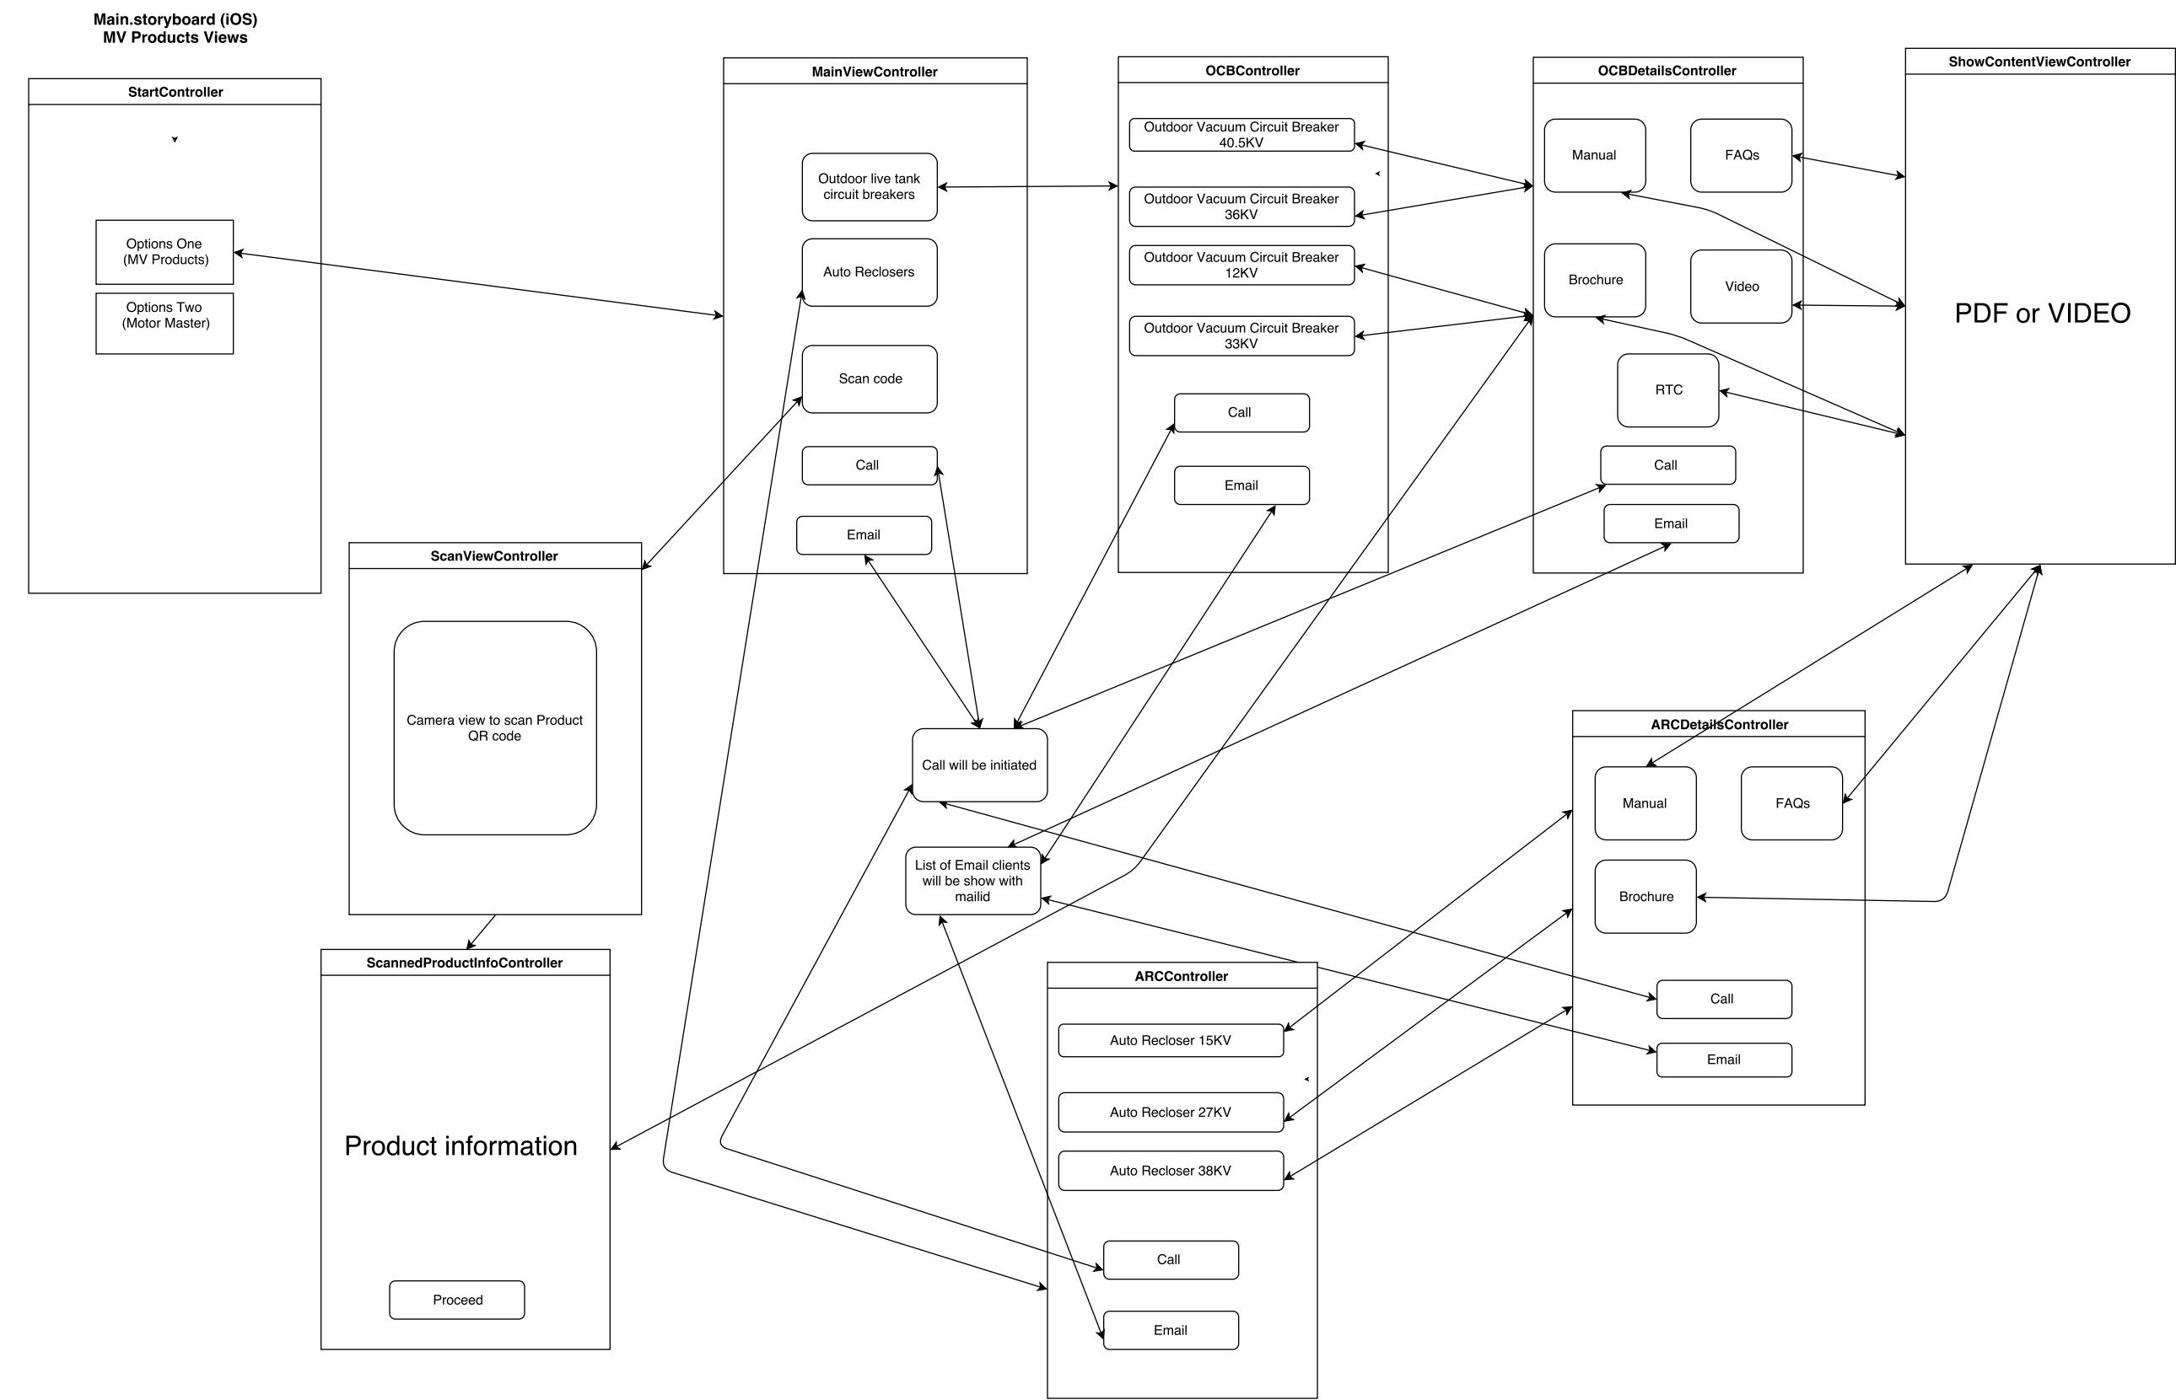
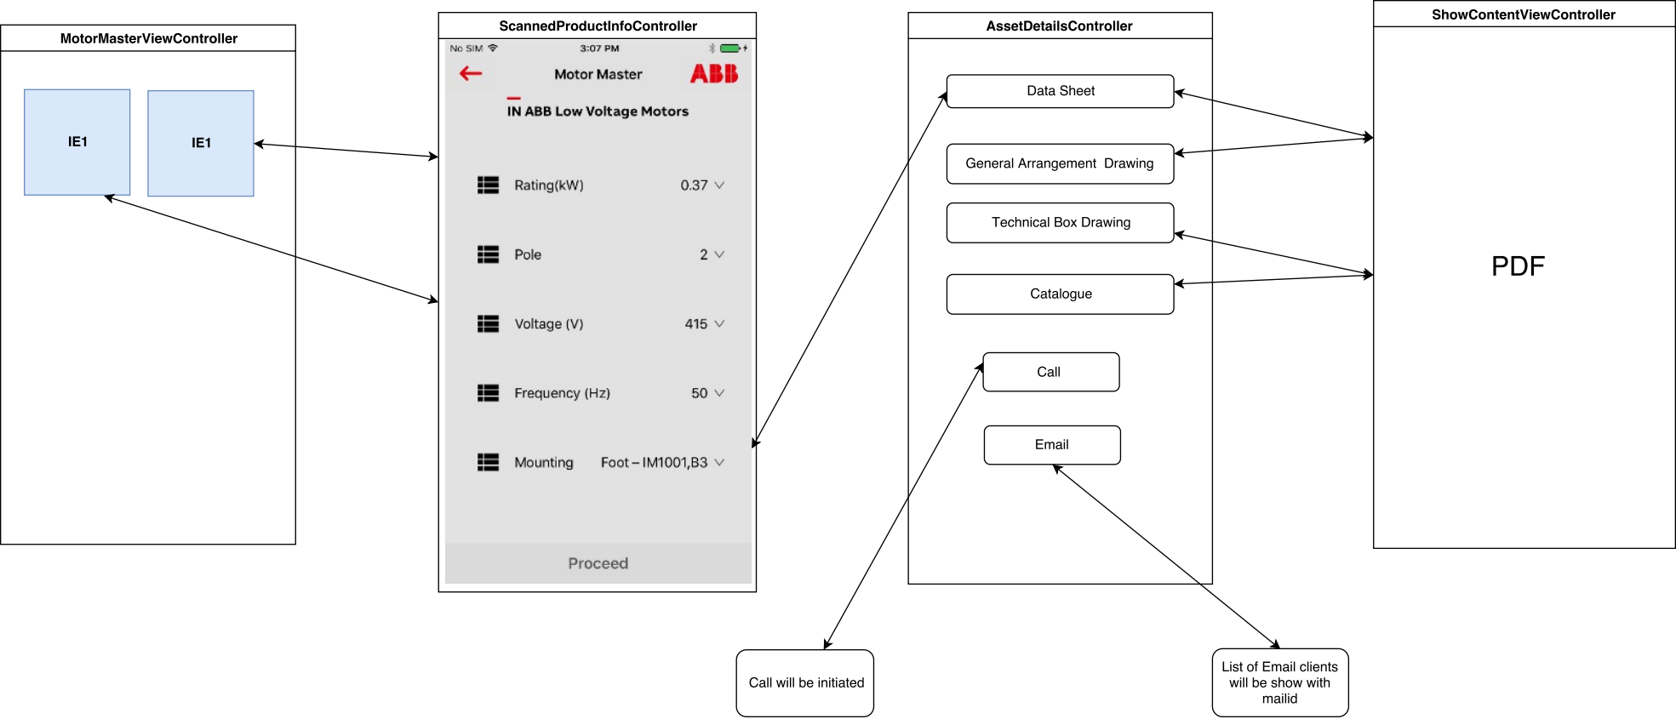

For Android

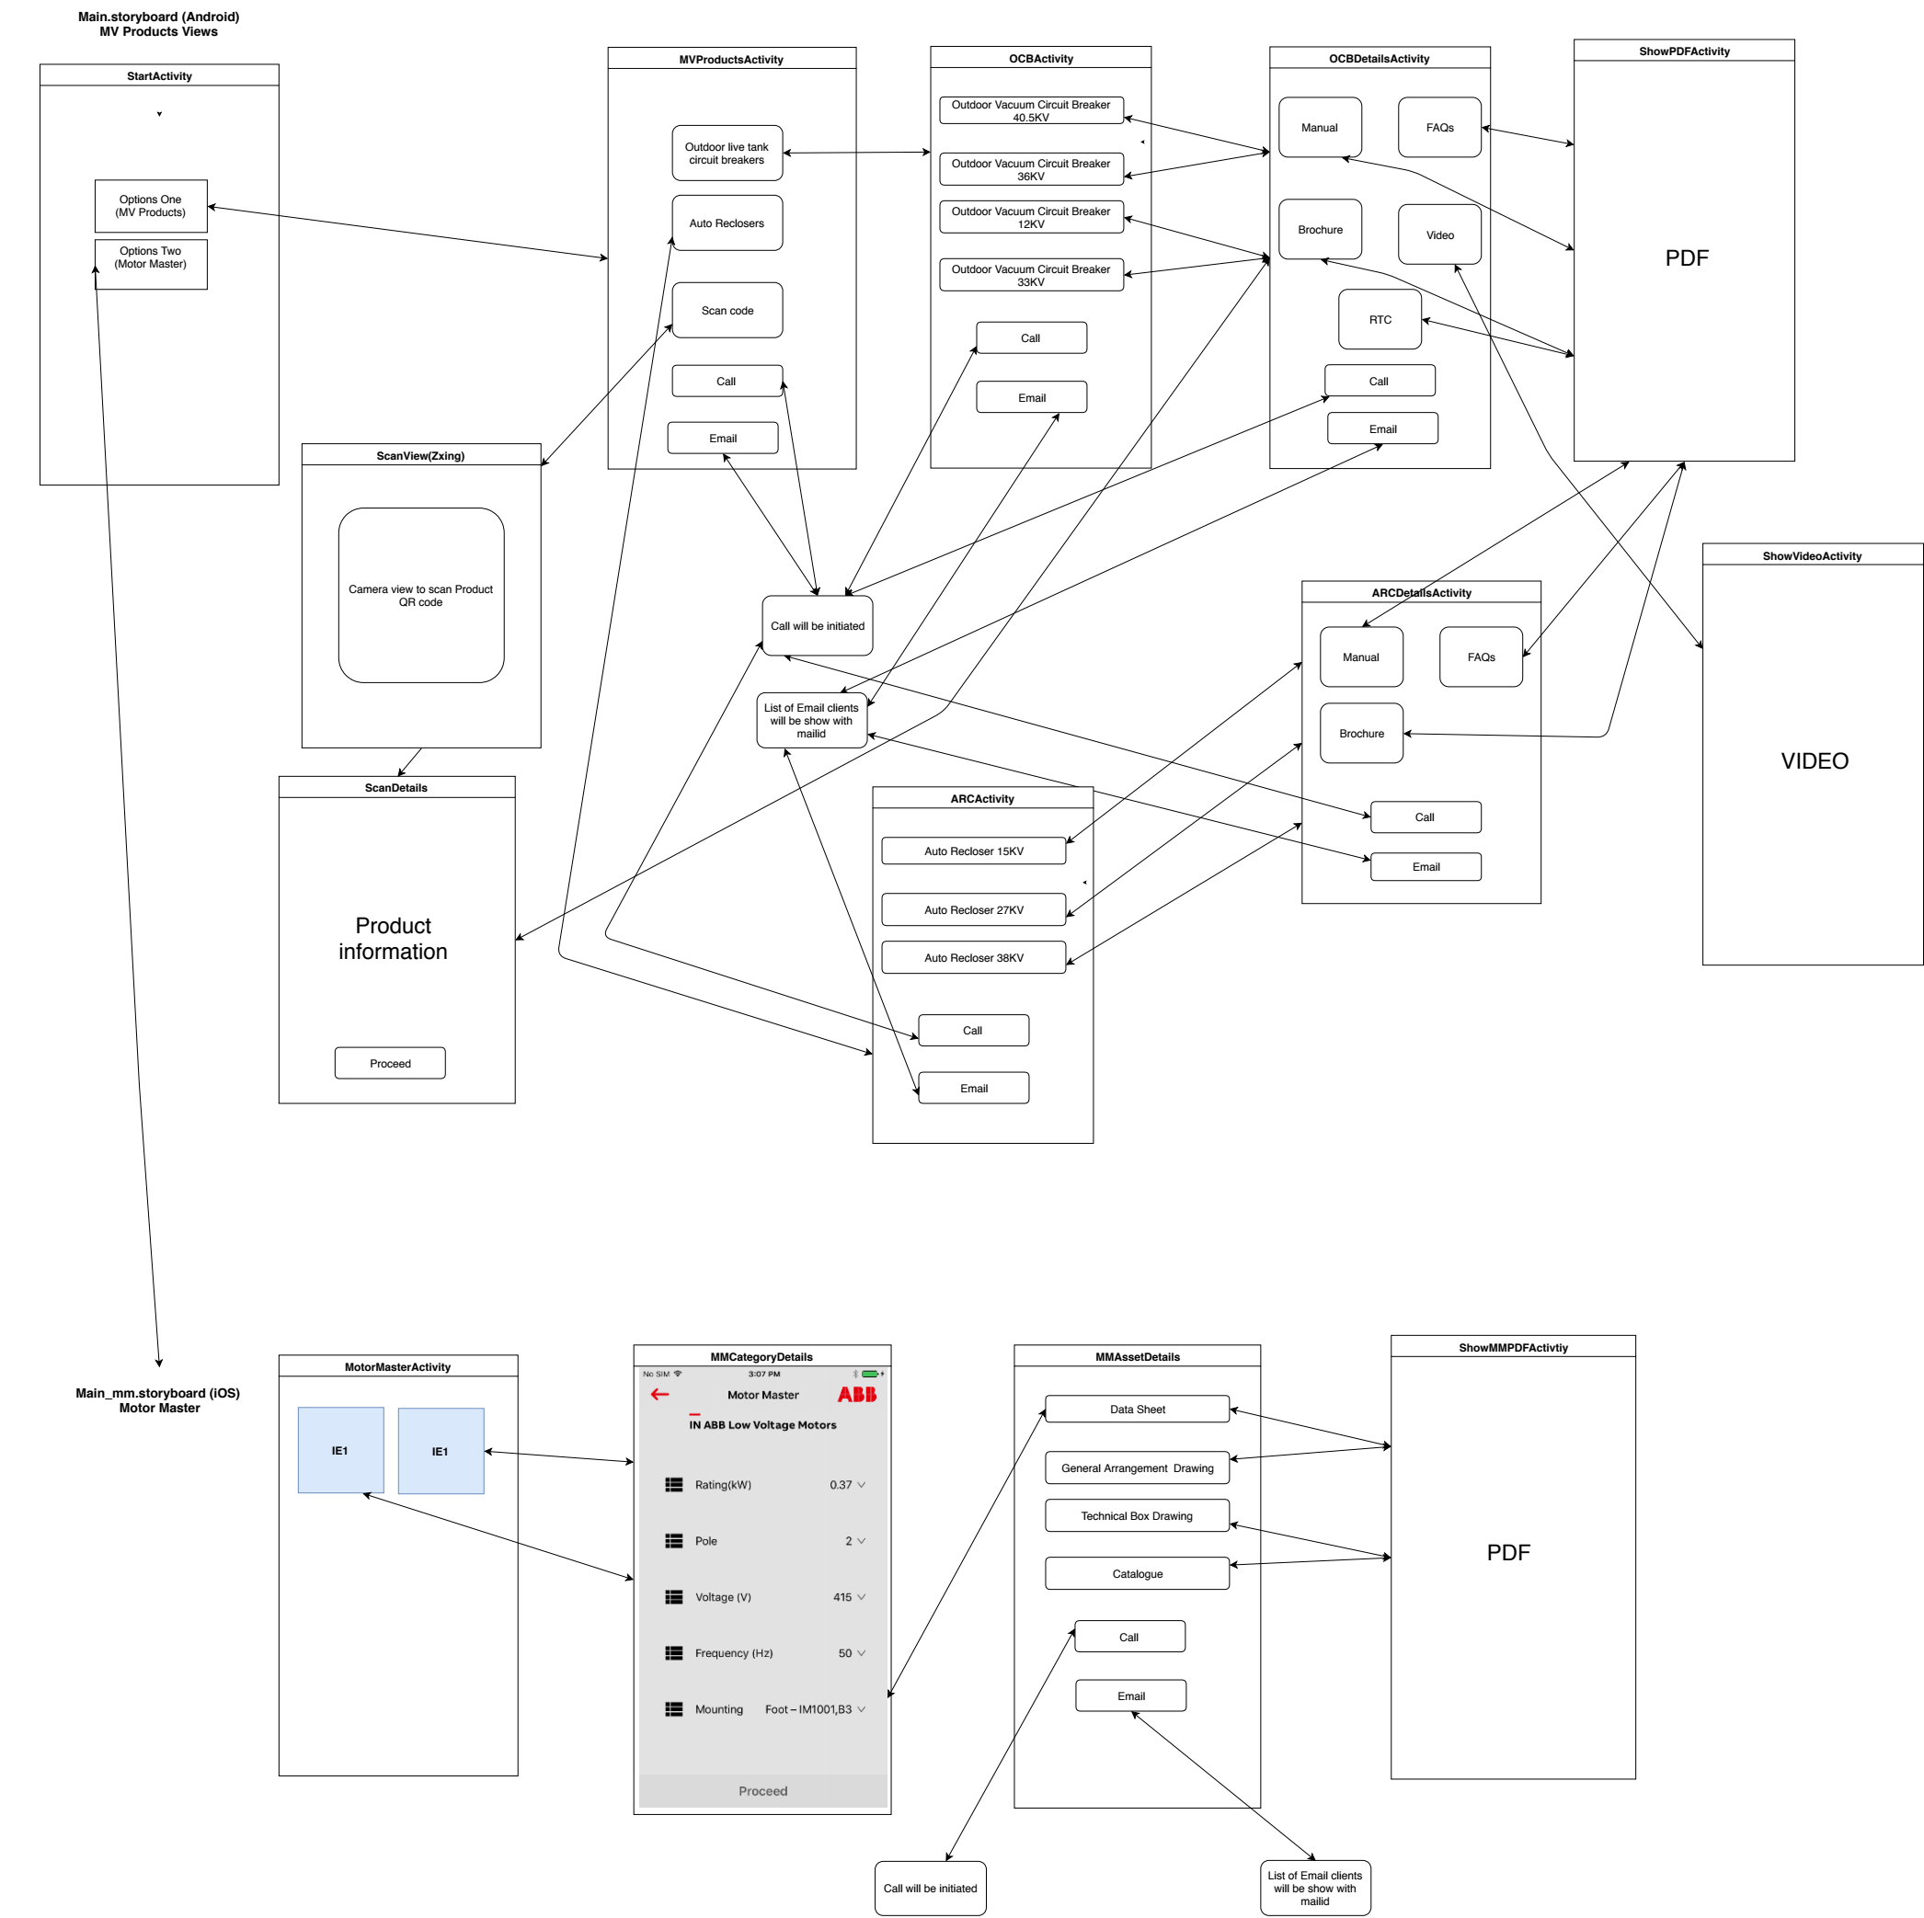

Detailed Class Design
Product List
Below class maintains the lis of products and based on selection app goes to respective screen
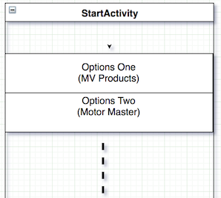

Android :: StartActivity
iOS :: StartViewController.

mainItems[0] = “MV Products”
mainItems[1] = “Motor Master”
// More items have to added when new product came in
// When User selects below operation executes
// If Selected Item equals mainItems[0] it goes to MV Products option
// If Selected Item equals mainItems[1] it goes to Motor Master option
// More options will be added below code...

if(mTitleTextView.getText().toString().contains(mainItems[0])){
startActivity(new Intent(getApplicationContext(),MVProductsActivity.class));
}
if(mTitleTextView.getText().toString().contains(mainItems[1])){
startActivity(new Intent(getApplicationContext(),MotorMasterActivity.class));
}

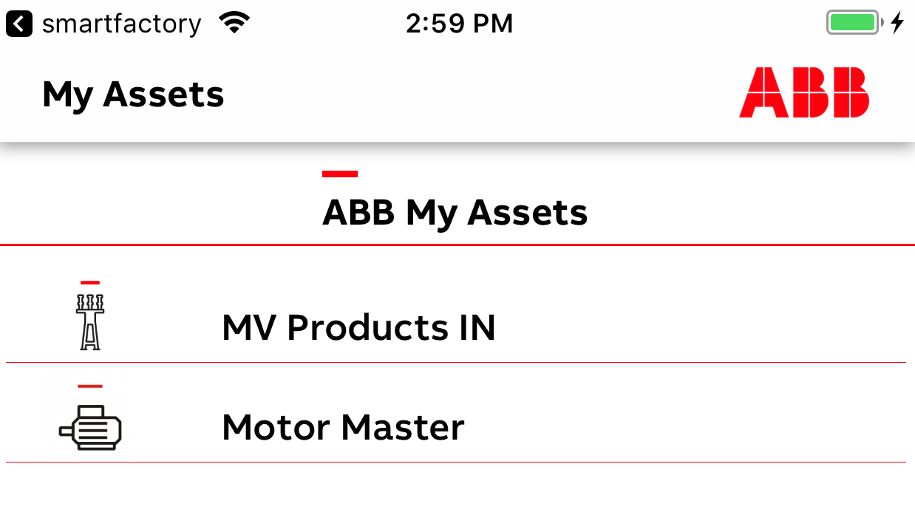
In the above screen more options can be added when there is a need and respective screen have to be linked with the product option.

All the screen UX is according ABB UX guidelines

MV Products (Product Page)

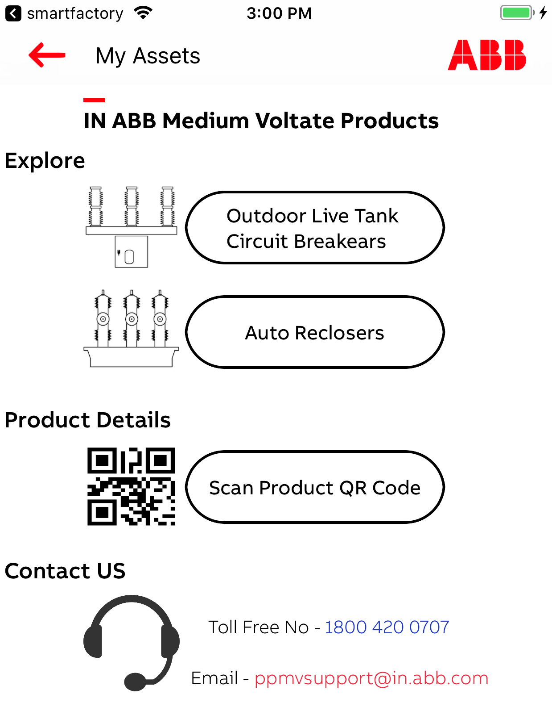

Android :: MVProductsActivity
iOS :: MainViewController

Outdoor Live Tank Circuit Breakers is Category of MV Products , Upon launch of it app goes to OCBActivity Screen as described in above overall flow

Auto Reclosers is Category of MV Products , Upon launch of it app goes to ARCActivity Screen as described in above overall flow

Scan Product QR code launch camera with QR code scanning capability.

// Out Door Circuit Breaker activity will be launched
binding.outdoor.setOnClickListener(new View.OnClickListener() {
@Override
public void onClick(View v) {
startActivity(new Intent(MVProductsActivity.this, OCBActivity.class));
}
});
// Auto Recloser activity will be launched
binding.autorecloser.setOnClickListener(new View.OnClickListener() {
@Override
public void onClick(View v) {
startActivity(new Intent(MVProductsActivity.this, ARCActivity.class));
}
});
// Product Scan activity will be launched
binding.scancode.setOnClickListener(new View.OnClickListener() {
@Override
public void onClick(View v) {
scanProduct();
}
});

OutDoor Live Tank Circuit Breakers / Auto recloser

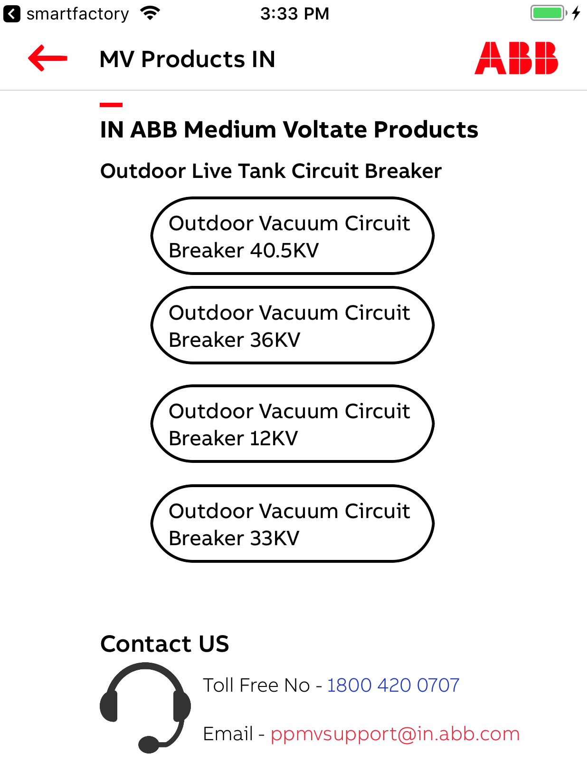

Android :: OCBActivity
iOS :: OCBController

OCB is one category in product and it has 4 variants

40.5KV First Variant

36 KV Second Variant

12KV Third Variant

33KV is Fourth Variant

More variants can be added later point

// outDoorOne is 40.5 KV variant
outDoorOne.setOnClickListener(new View.OnClickListener() {
@Override
public void onClick(View v) {
callDetails(outDoorOne);
}
});
// outDoorTwo is 36 KV variant
outDoorTwo.setOnClickListener(new View.OnClickListener() {
@Override
public void onClick(View v) {
callDetails(outDoorTwo);
}
});
// outDoorThree is 12 KV variant
outDoorThree.setOnClickListener(new View.OnClickListener() {
@Override
public void onClick(View v) {
callDetails(outDoorThree);
}
});
// outDoorFour is 33 KV variant
outDoorFour.setOnClickListener(new View.OnClickListener() {
@Override
public void onClick(View v) {
callDetails(outDoorFour);
}
});
Based on variant selected we choose some options to show, some options to not to show.
Below is the logic used to do same.

void callDetails(Button view){
Intent arcDetail = new Intent(OCBActivity.this,OCBDetailsActivity.class);
arcDetail.putExtra("prname",view.getText().toString());
arcDetail.putExtra("prid",view.getTag().toString());
arcDetail.putExtra("showrtc",false);
arcDetail.putExtra("showvideo", true);
arcDetail.putExtra("showbrochure", true);
if(view.getText().toString().contains("12kV")) {
arcDetail.putExtra("showvideo", false);
arcDetail.putExtra("showbrochure", false);
}
if (view.getText().toString().contains("36kV")) {
arcDetail.putExtra("showvideo", false);
}
startActivity(arcDetail);
}

OutDoor Live Tank Circuit Breakers is shown in above picture, Auto Recloser follows the same approach. Auto Recloser has 3 variants and they also use above logic to launch variant content details.

Variant Content options (Similar for both Outdoor live tank circuit breakers and Auto reclosers ).

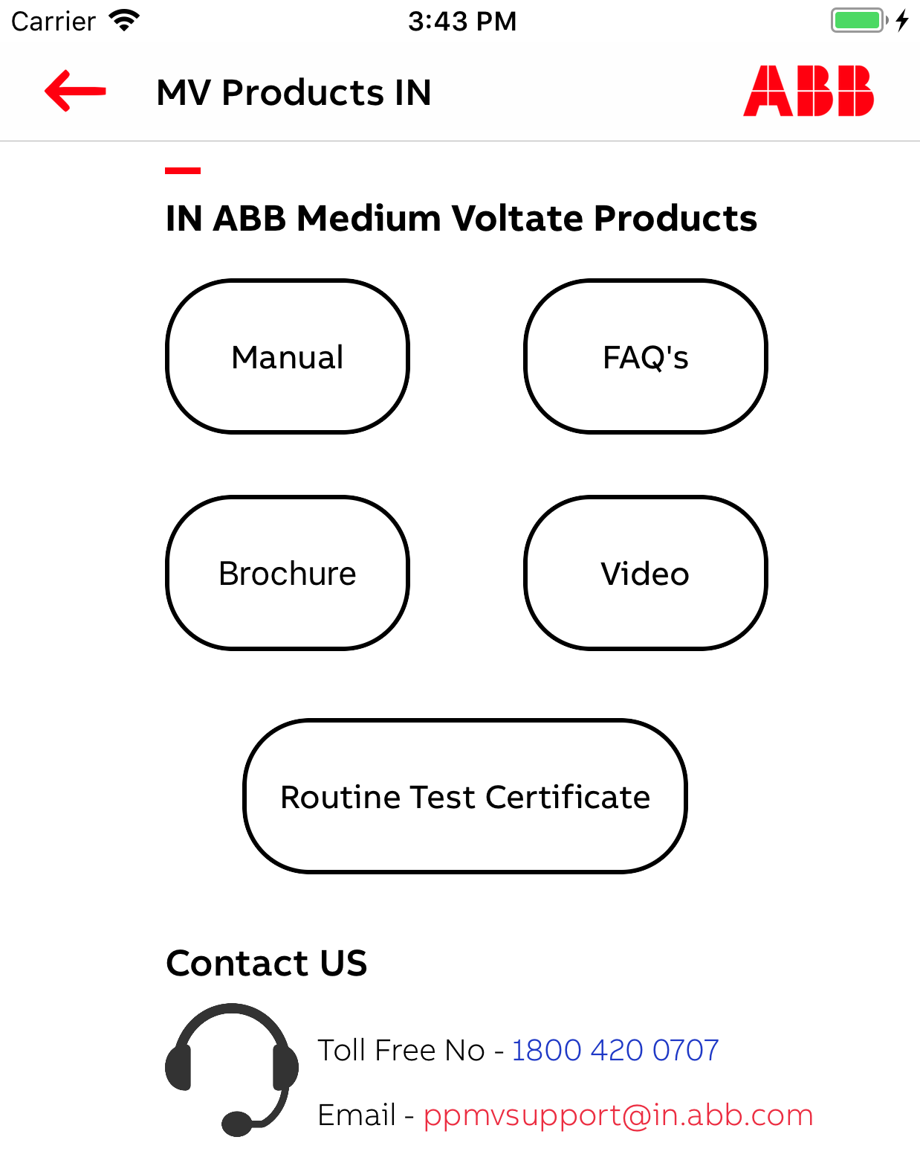
This screen shows various options of variant selected in previous screen
Here we fetch all the content related to selected variant from Azure cloud.

When user choose the options shown screen we open respective link in the content screen.

Outdoor live tank circuit breakers

Android : OCBDetailsActivity
iOS : OCBDetailsController

Auto Reclosers

Android : ARCDetailsActivity
iOS : ARCDetailsController

To get product details we have to use the REST api below with POST request and post parameters like below

Webkey = “ 0c29792b-3cf9-7215-9549-3afe6fd88e3f“ (for MV Products)
Webkey = “ a3c99ade-6cb4-e559-7182-2bc670890db7“ (for Motor Master)

productId varies with variant, below is the list to be used

// Product ID refers to Product Tag
// each Product Variant has code which is being taken as below case statements
case "OHB":
productTag = "11";
prodcutName = "Outdoor SF6 gas circuit breaker 33kV";
break;
case "OVR15":
productTag = "12";
prodcutName = "Auto recloser 15kV";
break;
case "OVR15 1":
productTag = "13";
prodcutName = "Auto recloser 15kV";
break;
case "OVR27":
productTag = "14";
prodcutName = "Auto recloser 27kV";
break;
case "OVR38":
productTag = "18";
prodcutName = "Auto recloser 38kV";
break;
case "SDB":
productTag = "15";
prodcutName = "Outdoor Vacuum Circuit Breaker 12kV";
break;
case "VBF EL3":
productTag = "16";
prodcutName = "Outdoor Vacuum Circuit Breaker 36kV";
break;
case "VBF":
productTag = "17";
prodcutName = "Outdoor Vacuum Circuit Breaker 40.5kV";
break;

let params : Parameters = [
"webkey" : APIConstants.mvWebKey,
"id" : self.prodId]

https://lvdrives-mobapi.azurewebsites.net/getProductDetails

The response for the above api is for the prodId = “17”

let params : Parameters = [
"webkey" : 0c29792b-3cf9-7215-9549-3afe6fd88e3f,
"id" : 17]

{
"status": "OK",
"data": {
"photo_blob": "https://lvdrives.blob.core.windows.net/scanner-docs/16.jpg",
"files": [{
"filename": "Manual",
"bloblink": "https://lvdrives.blob.core.windows.net/scanner-docs/VBF-03-01-manual-English.pdf",
"lang_ref": "eng",
"version": "1.0.0",
"created_date": "",
"description": ""
},
{
"filename": "Brochure",
"bloblink": "https://lvdrives.blob.core.windows.net/scanner-docs/VBF-03-01-Brouchre-English.pdf",
"lang_ref": "eng",
"version": "1.0.0",
"created_date": "",
"description": ""
},
{
"filename": "RTC",
"bloblink": "https://lvdrives.blob.core.windows.net/scanner-docs/RTC/VBF/",
"lang_ref": "eng",
"version": "1.0.0",
"created_date": "",
"description": ""
},
{
"filename": "Video link",
"bloblink": "https://lvdrives.blob.core.windows.net/scanner-docs/ABB-OVB.mp4",
"lang_ref": "eng",
"version": "1.0.0",
"created_date": "",
"description": ""
},
{
"filename": "FAQs",
"bloblink": "https://lvdrives.blob.core.windows.net/scanner-docs/FAQ%20for%20outdoor%20breakers.pdf",
"lang_ref": "eng",
"version": "1.0.0",
"created_date": "",
"description": ""
}
]
}
}

The controls to content page is taken from below code.

// manual option selected it goes to show page with manual option preset.
manual.setOnClickListener(new View.OnClickListener() {
@Override
public void onClick(View v) {
callShowPage(manual);
}
});
// brochure option selected it goes to show page with brochure option preset.
brochure.setOnClickListener(new View.OnClickListener() {
@Override
public void onClick(View v) {
callShowPage(brochure);
}
});
// video option selected it goes to show page with video option preset.
video.setOnClickListener(new View.OnClickListener() {
@Override
public void onClick(View v) {
callShowVideo(video);
}
});
// rtc (Routine test certificate) option selected it goes to show page with rtc option preset.
rtc.setOnClickListener(new View.OnClickListener() {
@Override
public void onClick(View v) {
callShowPage(rtc);
}
});
// faqs option selected it goes to show page with faqs option preset.
faqs.setOnClickListener(new View.OnClickListener() {
@Override
public void onClick(View v) {
callShowPage(faqs);
}
});
The data shown in json response has multiple links which maps one to one with above options.

Here is the mapping

For manual

"filename": "Manual",
"bloblink": "https://lvdrives.blob.core.windows.net/scanner-docs/VBF-03-01-manual-English.pdf",

For Brochure

"filename": "Brochure",
"bloblink": "https://lvdrives.blob.core.windows.net/scanner-docs/VBF-03-01-Brouchre-English.pdf",

For FAQ’s

"bloblink": "https://lvdrives.blob.core.windows.net/scanner-docs/FAQ%20for%20outdoor%20breakers.pdf",

For Video

"filename": "Video link",
"bloblink": "https://lvdrives.blob.core.windows.net/scanner-docs/ABB-OVB.mp4",

For RTC (Routine test certificate)
This option comes only when QR code is scanned and proceeds to product info.

"bloblink": "https://lvdrives.blob.core.windows.net/scanner-docs/RTC/VBF/",
"lang_ref": "eng",

These links will be given to ShowContent screen, same shown in that page (either PDF or Video).

Content Screen : Display Either PDF or Video (Below shown PDF)

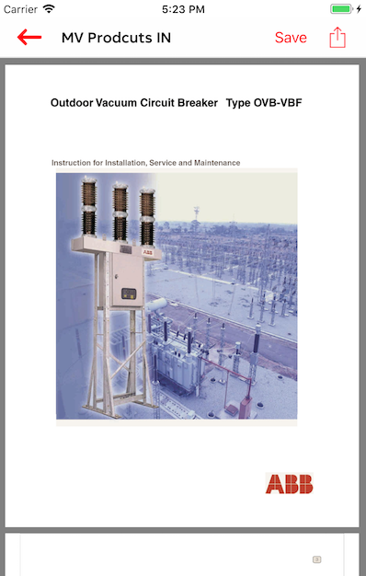

This screen fetches the content (PDF or Video) from the links provided from previous options chose and same will be displayed in the app.

It has two options on top one is save (downloads locally), and share. Share will gives the link of the content and text added
app information added.

Share options are shown in below diagram.

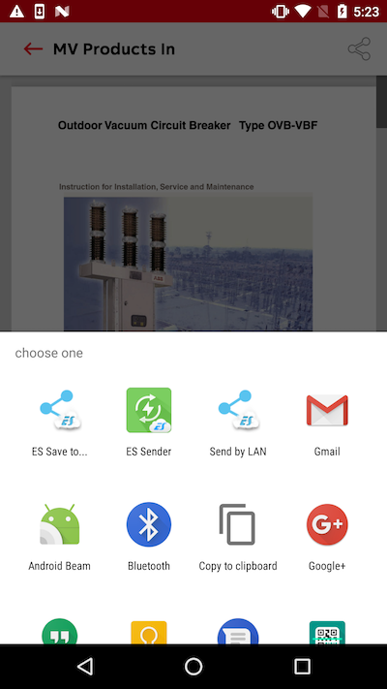

Scan View (Depends on Zxing SDK)
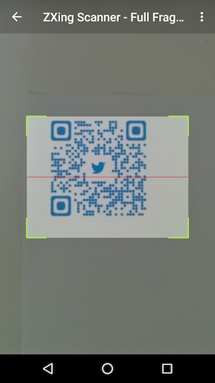
Android : Zxing SDK takes care of the screen (full view camera opens)
iOS : ScanViewController

When user choose Scan Product QR code , App opens camera with QR code scanning capability (this capability enabled by third part sdk which is Zxing). We set callback to this SDK and app gets callback called with scanned data.

In case of Android we create IntentIntegrator object provided by Zxing sdk and when Scan button pressed, app initiate the scan

Android
integrator.setOrientationLocked(false);
integrator.initiateScan();
iOS
We set callback as ScanResultDelegate to ScanviewController which returns the result on successful scan
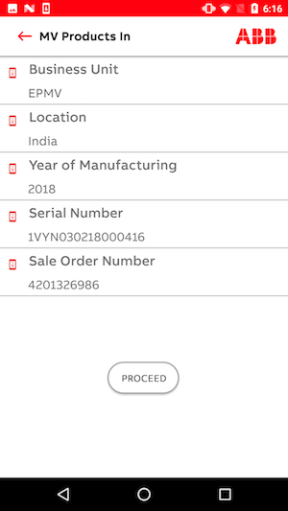
On QR scan we receive text below
“4201326986-201702-INABB-PPMV-VBF- EL3-1VYN030218000416”

This code contains information about the product , We parse the same and show below screen with details.

When user presses proceed button shown in screen , app goes to variant content option screen. And we get the details of the product
with code embedded in scan code.

Variant content screen will work as usual.

Motor Master (Product Page)
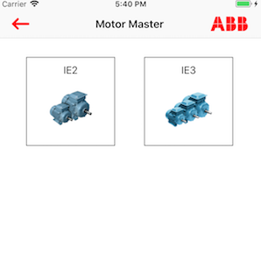

Android : MotorMasterActivity
iOS : MotorMasterViewController

In this screen we show product categories which are IE2 and IE3.

When user choose the option, App goes to variant selection screen

MotorMaster Variant
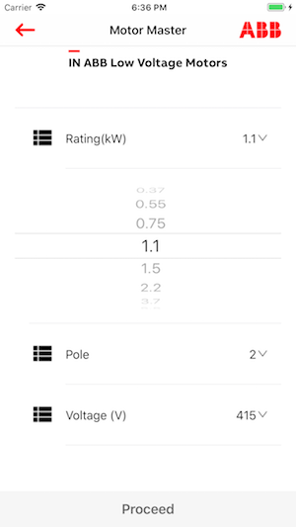

Android : MMCategoryDetails
iOS : AssetDetailsController

This screen show different options available of Product category selected.

We fetch all available variant details from the REST API with post request parameters used here are

webkey = “a3c99ade-6cb4-e559-7182-2bc670890db7”
category = “IE2” (Selected product category)

let params : Parameters = [
"webkey" : APIConstants.mmWebKey,
"category" : category]

https://lvdrives-mobapi.azurewebsites.net/
getAssetParamValues_mm

Response to above API is

{
"status": "OK",
"data": {
"rating": [
"0.37",
"0.55",
"0.75",
"1.1",
"1.5",
"2.2",
"3.7",
"5.5",
"7.5",
"9.3",
"11",
"15",
"18.5",
"22",
"30",
"37",
"45",
"55",
"75",
"90",
"110",
"125",
"132",
"160",
"200",
"250",
"315",
"355"
],
"pole": [
"2",
"4",
"6"
],
"voltage": [
"415"
],
"frequency": [
"50"
],
"mounting": [
"Foot – IM1001,B3",
"Flange – IM3001,B5",
"Foot & Flange – IM2001,B35",
"Face – IM3601,B14"
]
}
}

Based on above response we show form with options.

Rating option will show all the options we see in json rating part, etc…

After showing all the options, we enable user to choose variant combination.
After selection combination, when proceed button is pressed, We go to Variant Content options page.

Variant Content Options (Motor Master)
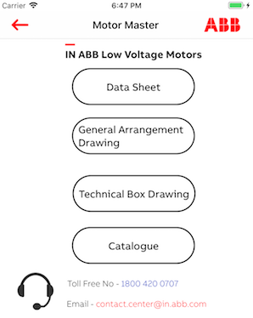
Android : MMAssetDetails
iOS : DetailsViewController

This screen fetches the content links related to selected combination from previous screen.

To fetch the content for the combination we use below REST API.

webkey = “a3c99ade-6cb4-e559-7182-2bc670890db7”
category = “IE2” (Selected product category)

let params : Parameters = [
"webkey" : APIConstants.mmWebKey,
"category" : category,
“pole” : 2,
“voltage”: 415,
“mounting”: "Foot – IM1001,B3",
“frequency”:50,
“rating” : 0.37
]
https://lvdrives-mobapi.azurewebsites.net/getAssetParamValues_mm
The response for the above API is below.

{
"status": "OK",
"data": {
"category": "IE2",
"kilowatt": "0.37",
"pole": "2",
"mounting": "Foot – IM1001,B3",
"voltage": "415",
"frequency": "50",
"frame size": "M2BAX71MA2",
"datasheet_reference": "3GBA071310-ASCIN_415.50",
"gad_reference": "3GZC500007-11",
"catalogue": "IE2 General performance catalogue",
"terminal_box": "3GZH500007-1"
}
}

When DataSheet options is used we create a link using below format.
Baseurl = https://lvdrives.blob.core.windows.net/myassets-docs/

DatasheetUrl = Baseurl + “3GBA071310-ASCIN_415.50.pdf”
GeneralArrangementDrawingUrl = Baseurl + “3GZC500007-11.pdf”
CatelogueUrl = Baseurl + “IE2 General performance catalogue.pdf”
TerminalBoxUrl = Baseurl + “3GZH500007-1.pdf”

We create these url on the go and provide this to Content screen which is described below.

Motor Master Content Screen

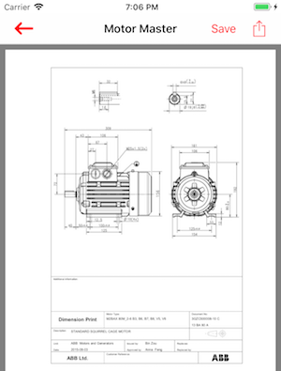

Android : ShowMMPDFActivity
iOS : ShowMMContentViewController

This screen just behave as MV Products Content screen with no Video support.

It shows all the content to with selected combination and share option as like explained earlier.

Process View

<Where are the threads of control in the application?>

Physical View
<Where will major components be physically deployed?>

Use Case View
<Sketch architecturally significant use cases.>

